PROFESSIONAL COACHING
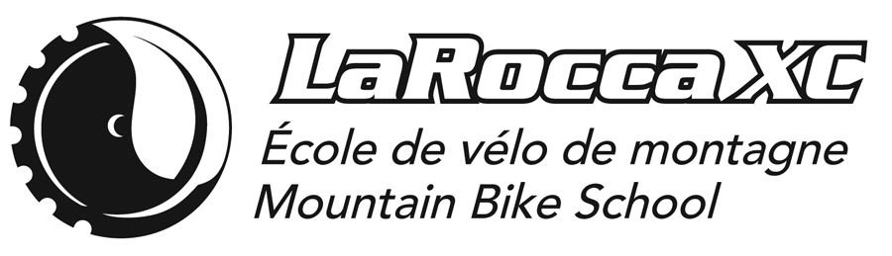
INDIVIDUAL / GROUP COACHING (CO-ED | WOMEN ONLY | FAMILY)
TRAIL PASS included.
Does not include GST & QST
FULLY BILINGUAL
Head Coach: Dominique Larocque, M.A.

Dominique was the dominant female XC MTB racer (1991 MTB National team) and cyclocross racer in Eastern Canada in the late 80’s and early 90’s, racing for Trek USA and Rollerblade Canada. With a propensity for boredom and collaboration, she redirected her passion for speed to inline and marathon speed skating racing in 1992, where she quickly became the dominant force in Canada and the US. She proved her international status in marathon speedskating during the Finland 100 km Ice Marathon in Kupio and the Athens to Atlanta marathon in 1994. She won the national inline skating title in 1996, prior to her retirement, declining an invitation to train on ice in Calgary in preparation for the 1998 Nagano Olympics, choosing family, education and vocation over racing.
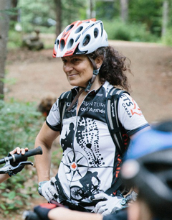
Her coaching debut took place at Camp Fortune in 1997 alongside her studies, combining Gestalt psychotherapy, energy healing and a master’s degree in Sport Psychology at the University of Ottawa (1997-2004).
In 2003, she decided to relocate her mountain bike school in Val-des-Monts to design a training facility that would guarantee the holistic success of her students and her full attention to her call as a coach and program/trail designer. She is fully dedicated in establishing her private coaching practice, her mountain bike school and her summer residence for many years to come in the Amik Forest. During the winter, she consults or works in the hospitality industry, which she loves with all her heart, for living, loving and learning are Dominique’s guiding life’s principles.
Her highly individualized and ‘out of the box’ coaching philosophy highlights the symbiotic relationship between mind, body and emotions. With the eye of a Jedi master, there’s not much she misses in her athlete’s riding style and psychological gridlocks. Dominique has developed a solid reputation through the years working with riders of all ages and riding abilities. Her dedication to her students is heart felt in every session she leads. Passion lives here!
PRIVATE MTB SKILLS COACHING
Fee for the first 90 minutes: $80 + taxes
For every additional 30 minutes: $25 + taxes

GROUP ADULT/FAMILY MTB SKILLS COACHING
(maximum 5 riders per group / preferably same level but not required).

Does not include GST & QST | 1st rider | 2nd rider | 3rd rider | 4th rider | 5th rider
Fee per rider for a 2-hour block instruction & trail pass | $80 | $70 | $60 | $50 | $40
For every additional hour for the group. | $25

We strongly encourage you to stay on site after your coaching session to practice,
go for a trail run, enjoy a picnic or simply relax on the site.

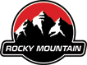
ROCKY MOUNTAIN RENTALS/DEMO ON SITE.

100% OF ALL PROCEEDS GO TOWARDS
THE SUSTAINABILITY OF THE AMIK PROJECT.

